Hack the Box(HTB) Machines Walkthrough Series- Enterprise

Continuing with the HTB machines as is started in the last article, this article contains the walkthrough of another HTB machine named Enterprise.

HTB is an excellent platform that hosts machines belonging to multiple OS. It also has some other challenges as well. Individuals have to solve the puzzle(simple enumeration + pentest) in order to login to the platform and can download the VPN pack to connect to the machines hosted on HTB platform.

**Note: Write ups of only retired HTB machines are allowed. The machine in this article termed as Enterprise is retired and thus the walkthrough.**

Let’s start with this machine.

1. Download the VPN pack for the individual user and use the guidelines to login to HTB VPN.
2. Enterprises machine IP is 10.10.10.61
3. We will adopt the same methodology of performing penetration testing. Let’s start with enumeration in order to gain as much information for the machine as possible.
4. As usual, let’s start with the nmap scan to gather more information around the services running on this machine.

**<<nmap -sC -sV -oA Enterprise 10.10.10.61>>**

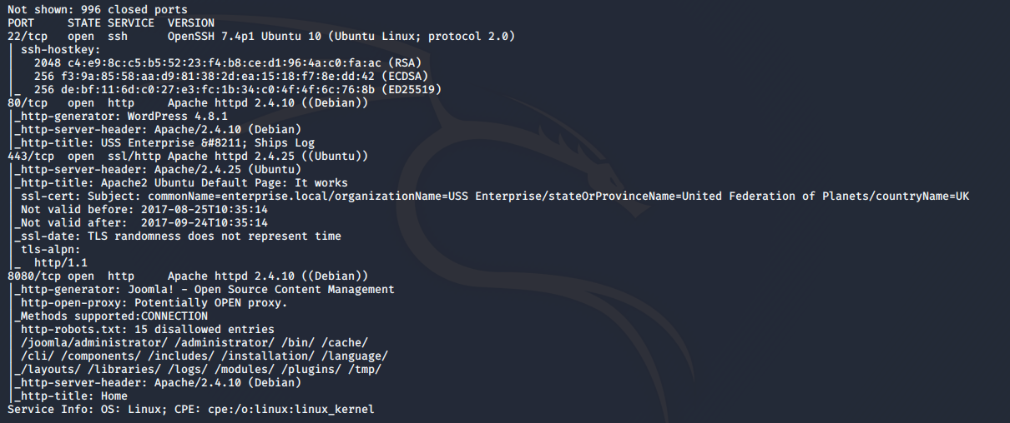



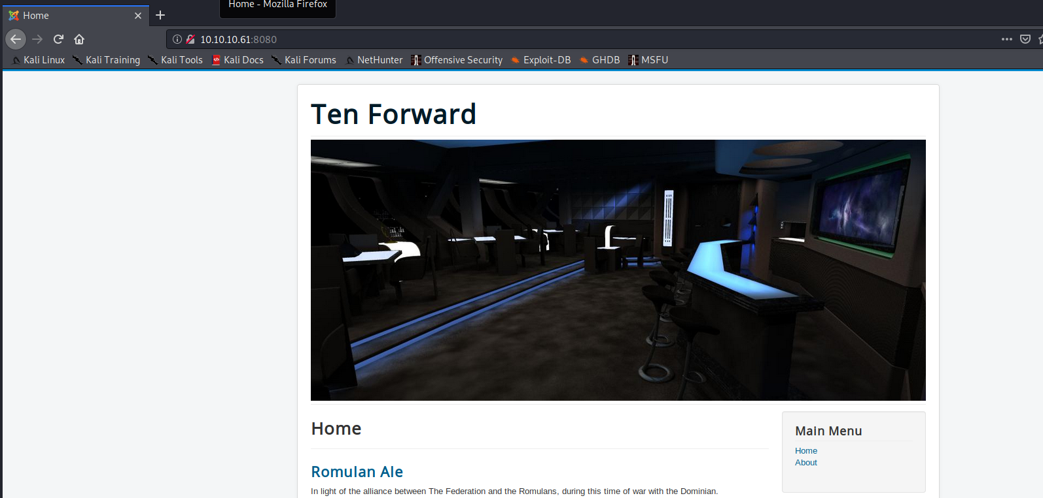

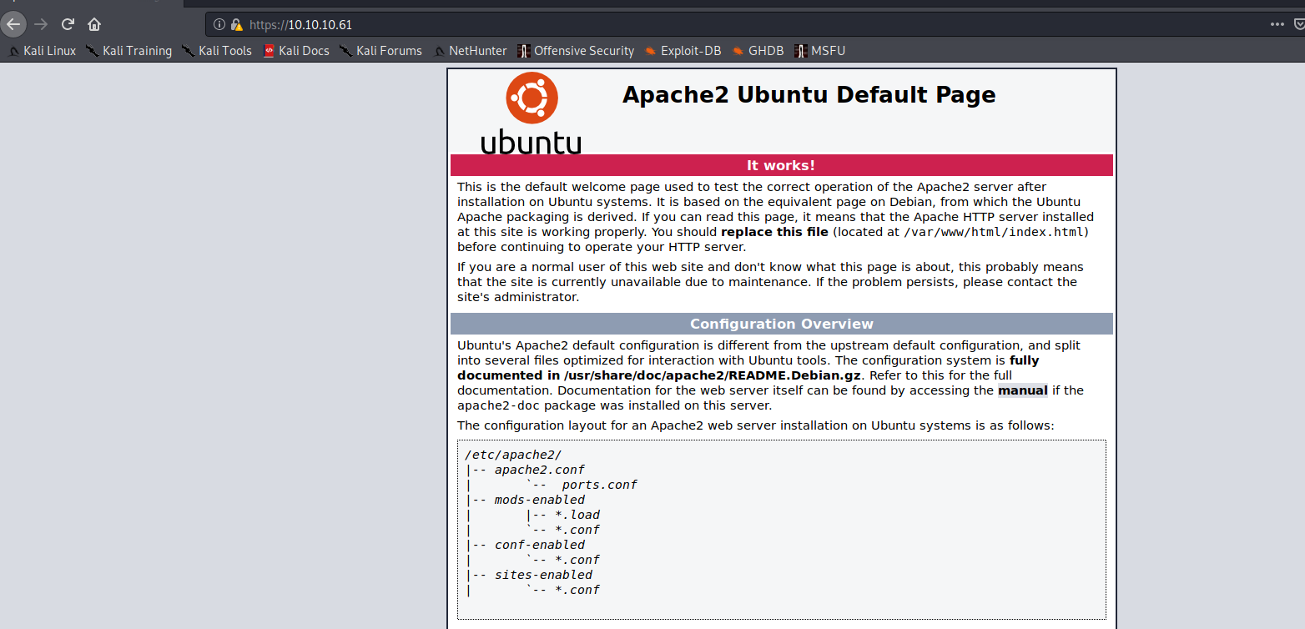

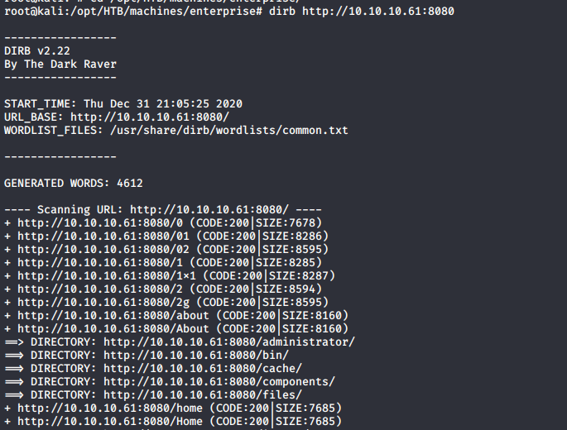

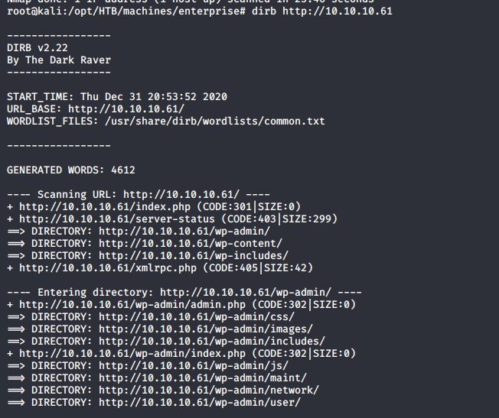

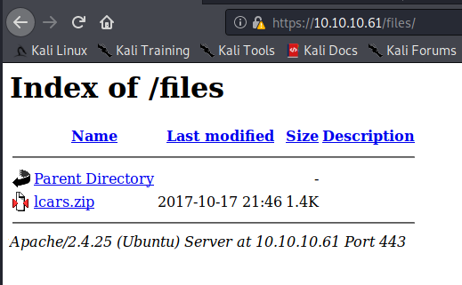

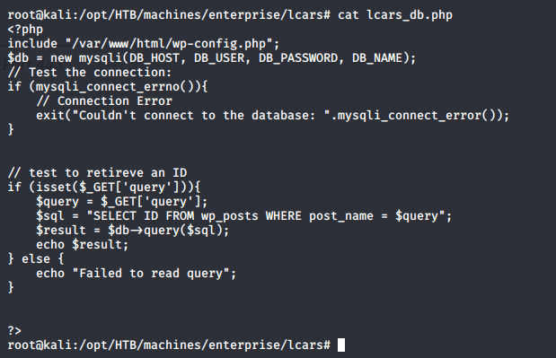

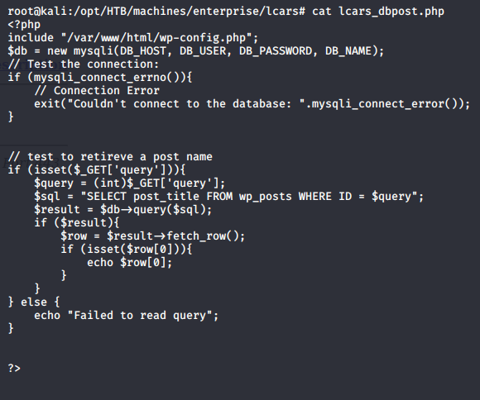

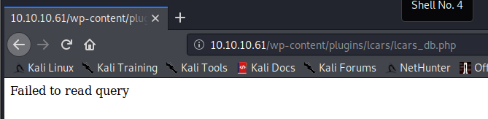

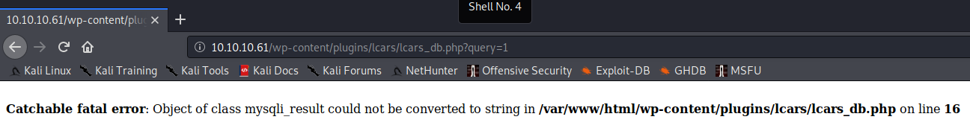

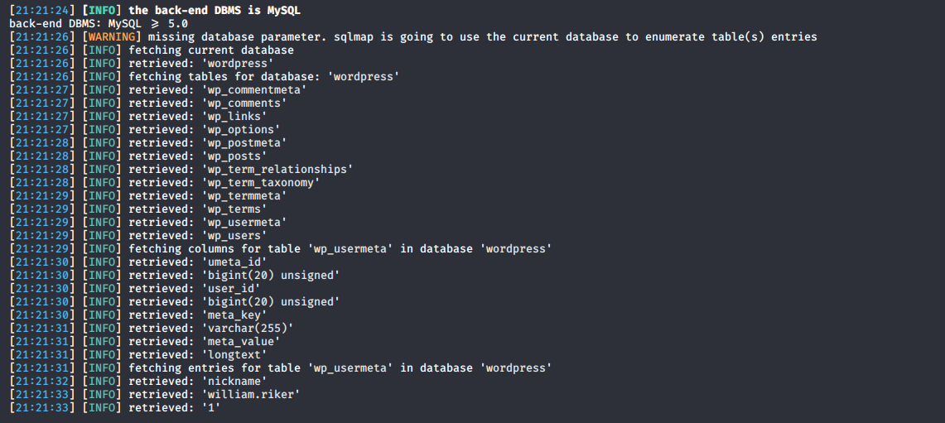

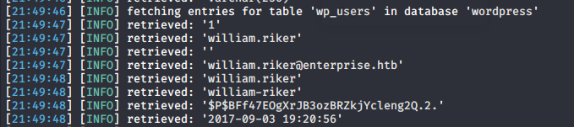

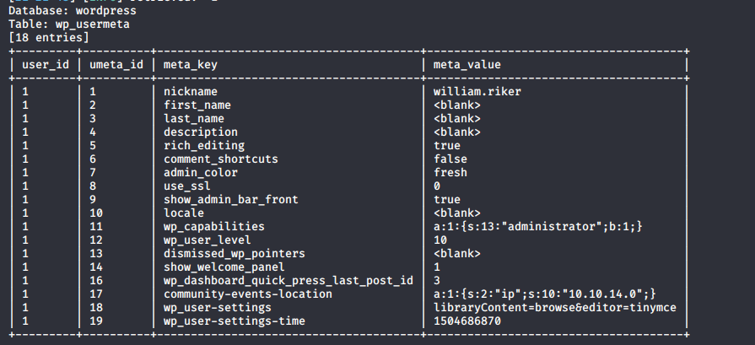

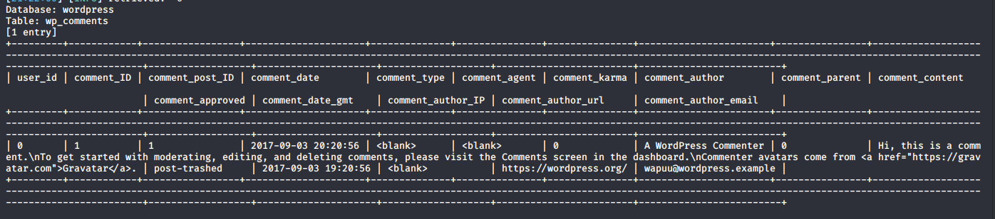



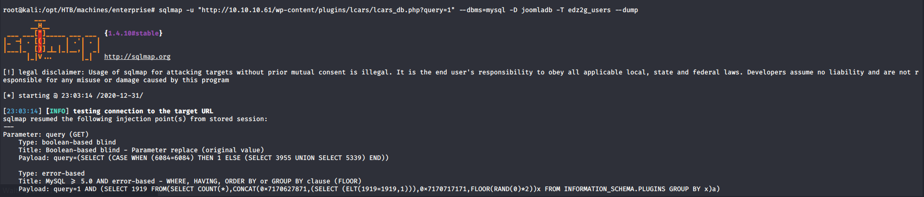

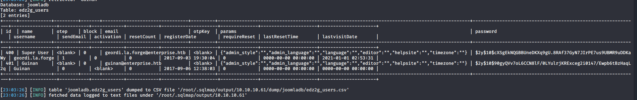

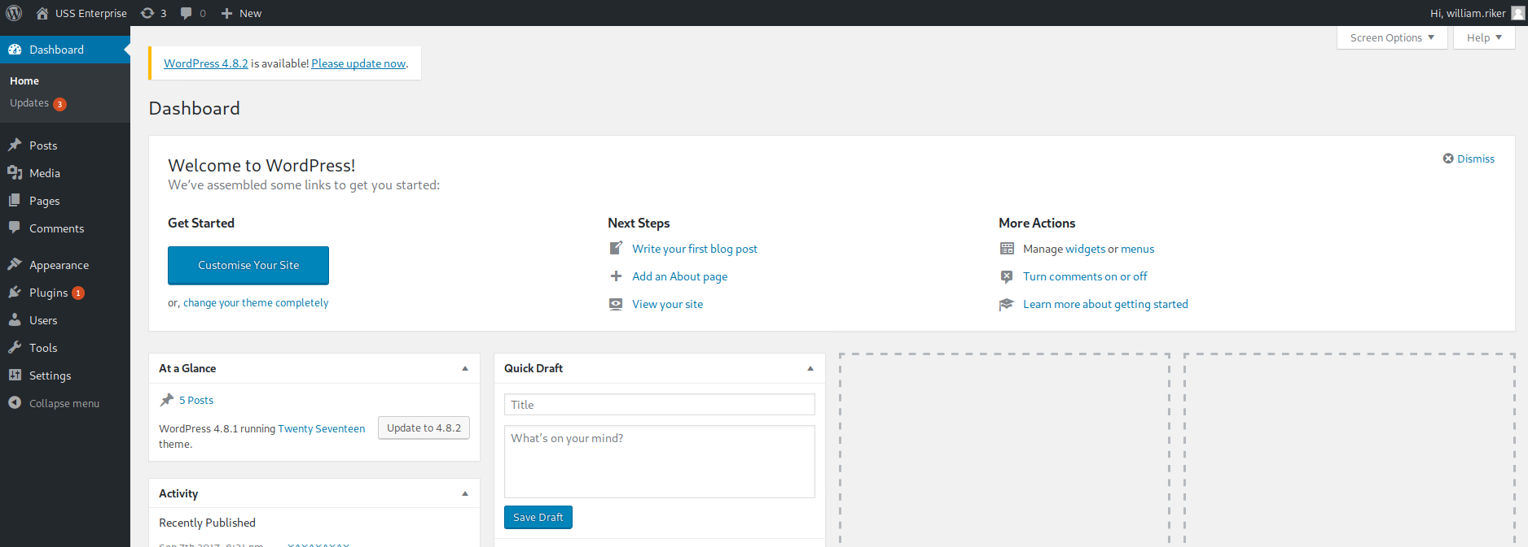

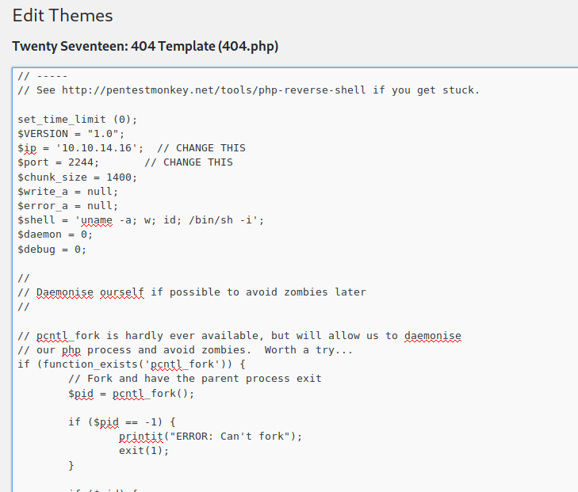

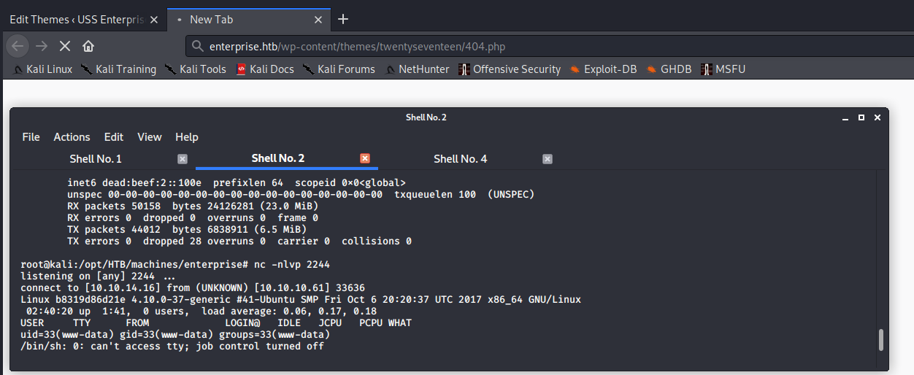

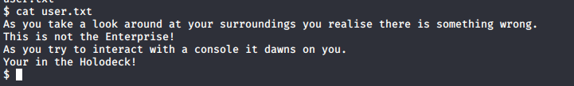

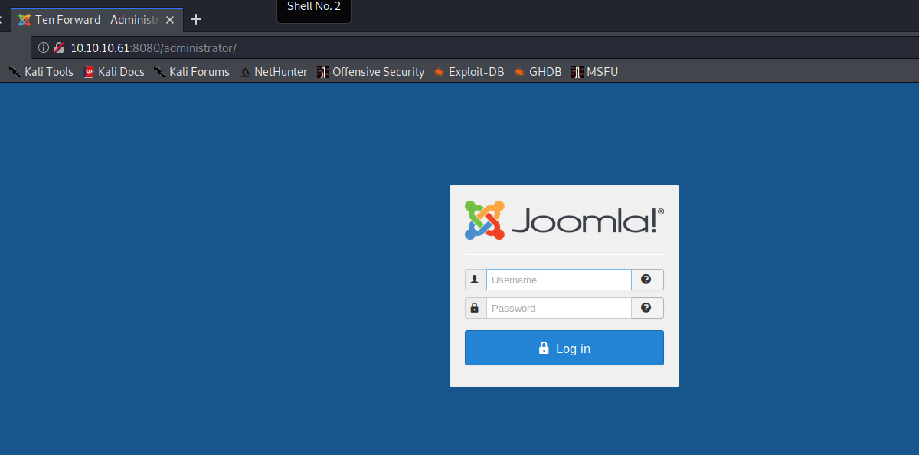

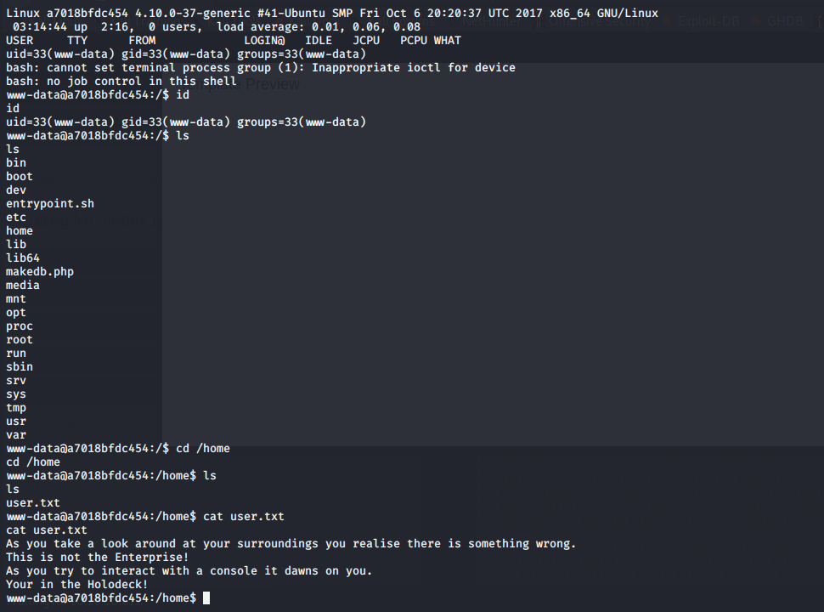

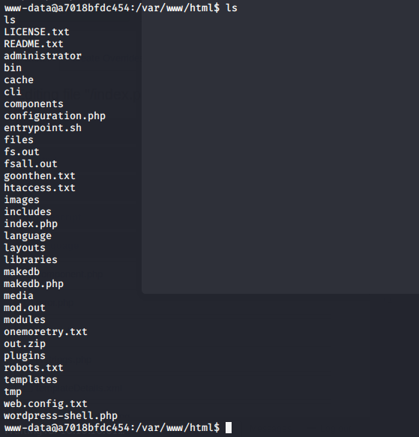

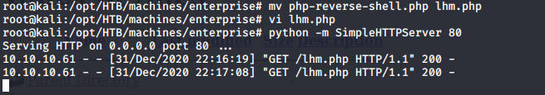

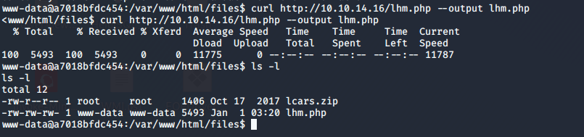

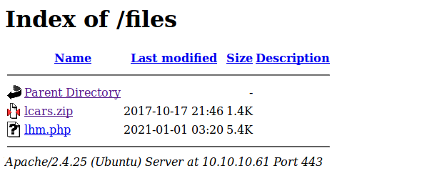

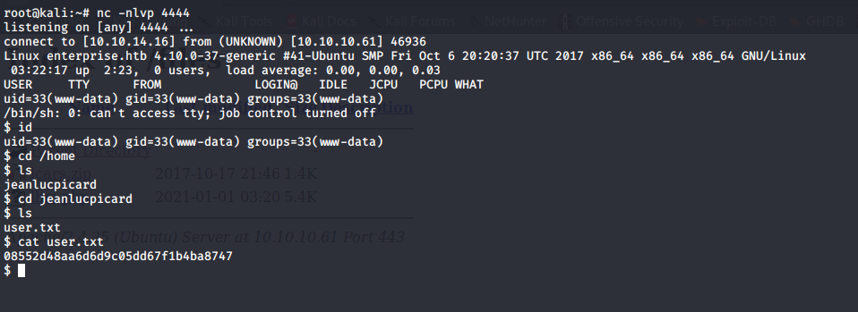

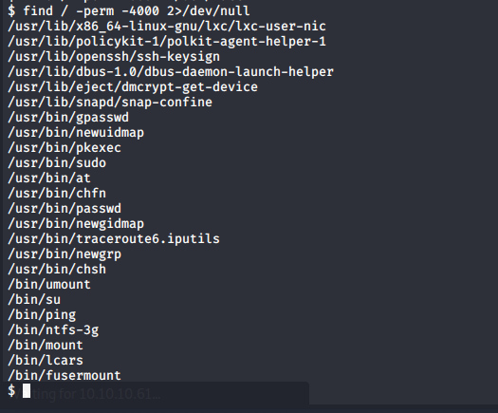

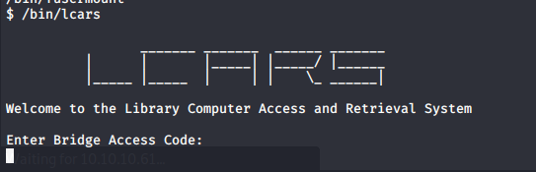

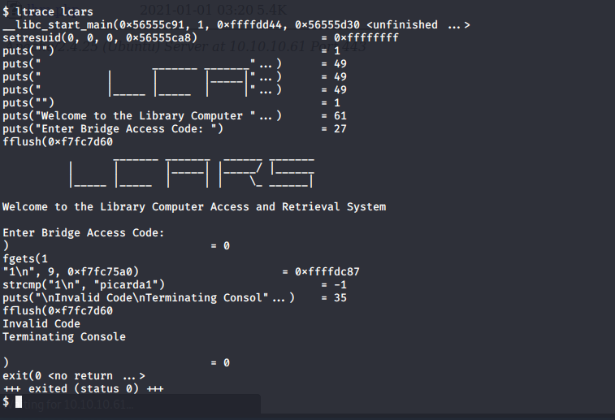

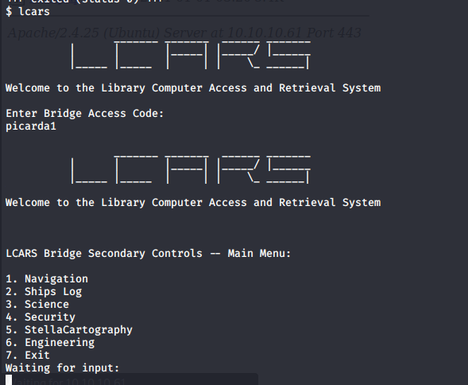



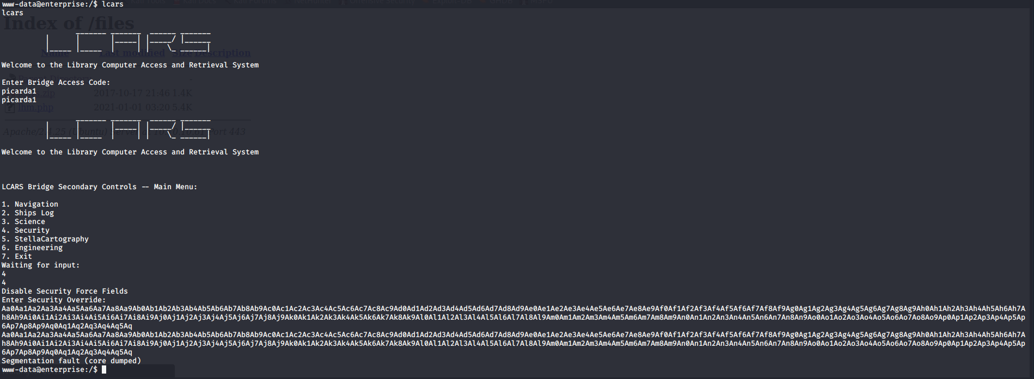

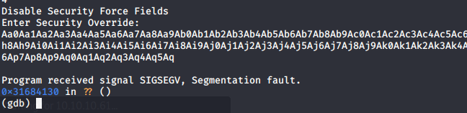





**Ret2libc**

